COSHH HAZARD & RISK ASSESSMENT SHEET |  |  |  |  |  |  |  |  |  |  |  |  | No.:
SUBSTANCE/PRODUCT NAME AND DESCRIPTION:

HAZARDOUS CONTENT |  |  |  |  | LTEL |  |  | STEL |  | CLASSIFICATION
 |  |  |  |  |  |  |  |  |  | 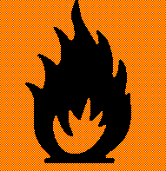
 |  |  |  |  |  |  |  |  |  | Flammable
HOW IS SUBSTANCE SUPPLIED, USED?

ASSESSMENT OF RISK, AND PRECAUTIONS TO BE TAKEN:

The PPE indicated below should be worn when working with this substance in the manner described. If site rules state other PPE must be worn at all times then the rules must be adhered to as well as the following recommendations.
 |  | 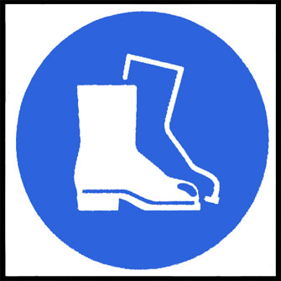 |  | 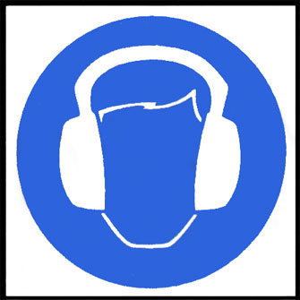 |  |  |  |  | 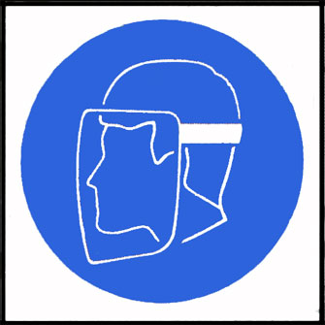 |  | 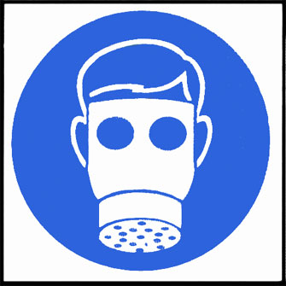 |  |  | 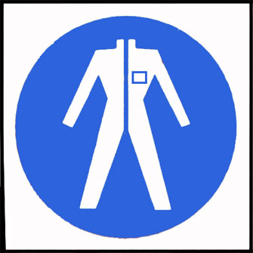
Eye  Protection must be worn | Safety footwear must be worn |  | Ear  defenders must be worn |  |  | Gloves  must be worn |  |  | Face  Masks must be worn |  | Respirators must be worn |  |  | Protective clothing must be worn
FIRST AID INFORMATION AND EMERGENCY ACTIONS

Eyes –.

Skin –.

Inhalation –

Ingestion –

Contaminated Clothing -

Fire

NB: If the product is being used in a manner different from the way
described above, a separate risk assessment will be needed

